MedCommons System Requirements Version 1.1

March 29, 2004

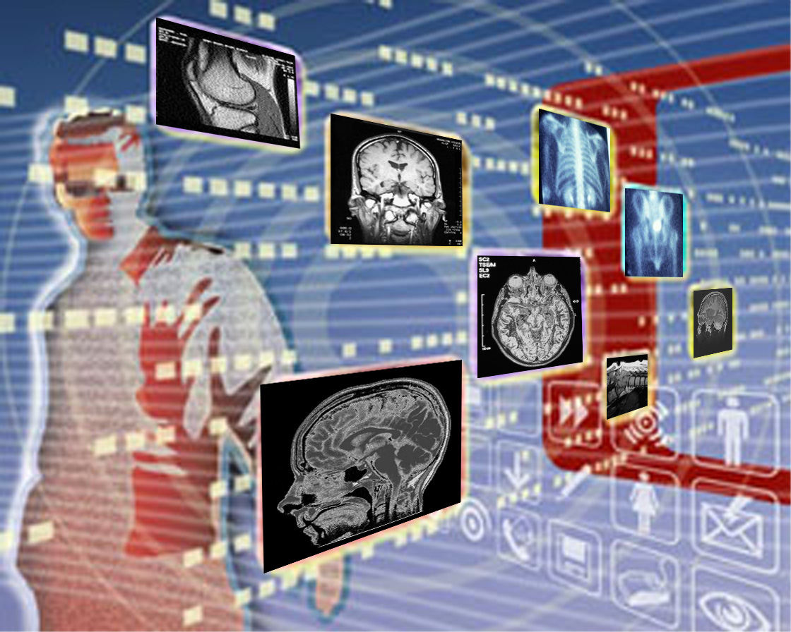

The following requirements have been added or modified since 0.992:

434, 803,805,806,826,831,832,841,887, 902-907, 921-923, 934-939, 941-946

This is release 1.1 – complete MedCOmmons requirements.

Editorial comments are italicized.
Requirements that are not applicable to the DEMO are highlighted.
The leftmost digit of a requirement number serves as a topical classifier. The 2nd digit encodes the Actor: (x2x-a real User, x3x-MedCommons Central, x4x-MedCommonsRouter, x5x-IntelligentAccessDevice, x6x-Central Webtop, x7x-Router Webtop, x8x-Forms Device,x9x-Modalities and 3rd Party Workstations,x0x and x1x are reserved for general requirements)

MedCommons Requirements Version 1.0 1
Introduction 3
000 Goals 4
100 Claims 5
200 Architecture 7
300 Hardware 9
400 MedCommons Central Facilities 12
500 Content Capture 13
600 Content Access and Update 15
700 Administration and Registration 21
800 Commerce 23
900 Security 28
1000 Cross References to Requirements by Actor 29

Unresolved Issues remaining in this version:

Families as a specific case of generic groups of individuals must be support for proxy account administration and maintenance.

Studies, and partial studies need to be more fully specified.

The relationship of studies and orders is fuzzy.

Introduction

This document is a requirements specification for MedCommons. MedCommons is a distributed system comprised of a half dozen or so major components all of which are worthy of their own individual specification. But in this document we are going to try and tie together the separate systems into a coherent whole, describing the behavior of each piece only to the extent it is necessary to understand the overall MedCommons business in order to write the individual specifications.

From a distance, MedCommons can be viewed as a large, secure, digital vault where all forms of Healthcare content can be stored for every individual in the country. This content can include radiological and cardiological images, medical reports as text, laboratory test results, dna sequences and generally, all forms of information still yet to be invented. It’s just a huge database, albeit one with some very important properties:

It is patient centric, and as a person accumulates for information about himself through the healthcare system, the patent’s content in MedCommons grows in kind.

It is managed, monitored, metered, backed-up, secured and audited according to FDA, HIPAA and other governmental requirements.

MedCommons provides ubiquitous access to its content via the Internet, but capturing content is another story. The medical devices and IT systems in the typical hospital or imaging center are normally not connected to the Internet, and are typically constructed so as to keep information inside the organization’s four walls. MedCommons provides the enterprise with a small device known as a Medical Router that moves content under patient control out of the enterprise and puts it into the large MedCommons database.

Getting content out of MedCommons into various devices and formats is straightforward, but it requires permission of both patients and occasionally physicians. This is accomplished via the Commerce component in MedCommons, which is directed by a signed Order Form specifying what needs to be done, and how it will be paid for.

That’s about all. The rest is just details which were jotted down in the margins of an earlier draft of this document, but were somehow lost in the shuffle.

000 Goals

This is a bit of a hodge-podge but it is important to keep these in mind:
001 Goal All Patient and Physician interactions pass the Grandmother Test. Roughly put, the Grandmother Test states that any semi-sentient technophobe can use MedCommons if they know how to use a credit card.
002 Goal Any individual patient or physician can adopt/join MedCommons unilaterally. This eliminates a great barrier to success.
003 Goal Transactional clarity and legal certification -21CFR11 – ISO 13485 – FDA 510[k] – HIPAA
004 Goal Do not demonstrate ‘Me Too’ features already promoted by InSiteOne, MMS,MICAS, MedWeb except as necessary.
005 Goal Clerks can perform routine cleanup and our Call Center picks up the rest.
006 Goal Doctors can collect patient studies in their own accounts although this requires copy functionality which is not planned for here.
007 Goals - The baseline Demo has only 4 clicks and one swipe as detailed below:

The careful reader will note that we are not signing on the Tablet as passing a Tablet to the patient to sign the form may not be grandmother-friendly. It certainly requires that the Clerk logs out and logs in as Guest (presumably using Windows XP rapid login) and then log in again. Also, the Tablet is kinda heavy and fragile for most grandmothers. If we wanted to use the tablet for gning demos beyond the "biometric" XP login, then it would need to be in a sturdy dock that swivels and the software woud edto enter a kiosk mode when the Order Form is displayed

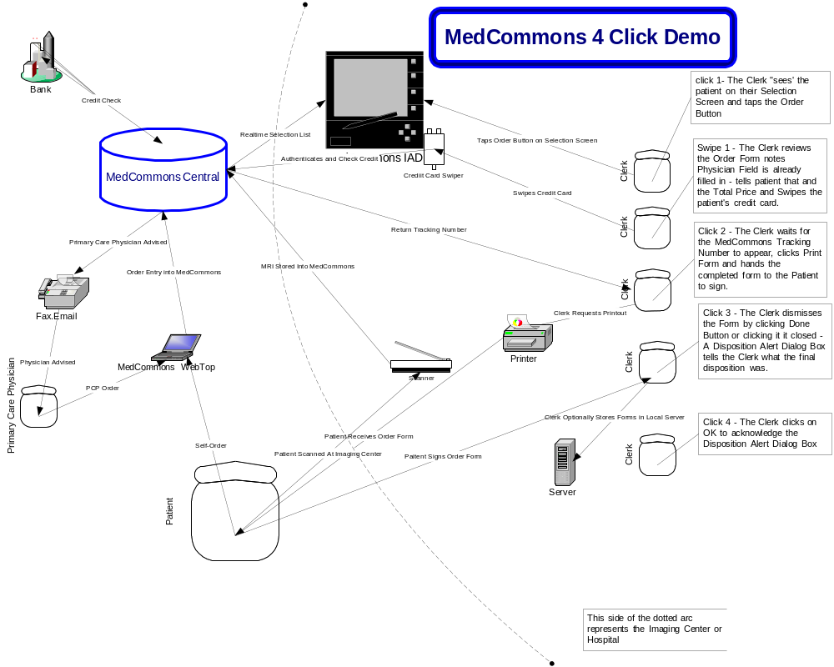

100 Claims

These are the public claims we need to make in order for the system to be useful and usable by the Medical community. In a future version of this document we will supply links to the underlying reference documents.
101 Claims FDA 21CFR11 and 510[k] filed and pending
102 Claims Disaster Recovery Claims – all content is redundantly stored in two geographically distinct repositories; switching from one repository to another is fully automatic and happens within minutes; validation of every object in each repository is automated and performed at least monthly
103 Claims IHE conformance and roadmap must be available (Adrian)
104 Claims ISO 13485 – Certification TBD
105 Claims DICOM and much of the Medical Router software is GPL and compatible with Community Development and Peer Review
106 Claims MedCommons will enhance and support existing DICOM implementations (DCM4CHE) with Web Services and a pluggable, HIPAA-compliant image transport capability. The initial Open Source, standards based transport supplied by MedCommons will be designed to encrypt, cross firewalls and work reliably on the WAN. As additional transport choices are plugged-in and available, the routers will use Web Services to dynamically negotiate the best choice
107 Claims Tablet / CC Version is installable by the receptionist after signing for FedEx.

200 Architecture

Loosely speaking, the system is made of a single central facility and its backup which will largely be constructed using Open Source Components, many distributed medical routers also constructed using mainly Open Source components, and 4 classes of access devices: plain old IE6 or better browsers, virtual forms devices as implemented by Adobe Acrobat or Microsoft Infopath, and Intelligent Access Devices of which there are two varieties: the plain old keyboard and mouse kind running Windows XP or better, and the Tablet and Pen based kind that support Ink and Handwriting Capture and run Windows XP Tablet edition. Additionally there will be credit card readers connected to the Intelligent Access Devices and printers connect to all types of access devices. We are separating the Browser and Forms Devices because we are uncertain as to the long term direction we want to take with forms handling, and are also uncertain as to whether all of the putative Infopath functionality will be available via Browsers.

201 Arch The MedCommons System is composed of a number of distinct components separated by primarily Web Services Interfaces. Or expectation is that by utilizing Web Services we are minimizing firewall and interconnectivity issues at the potential cost of some small performance loss.
202 Arch Except as specifically needed for connecting to medical devices, modalities, internet browsers and existing enterprise systems, or for significant performance enhancements, all interfaces are implemented as Web Services
203 Arch The Open Source components of the System are explicitly distinct from the Proprietary components of the System and will have different web service URIs even if collocated on the same hardware devices. WS interfaces will be used to separate Open Source from the Proprietary systems and subsystems of MedCommons. This will add value by making it clear that we are not "linking" GPL code with our proprietary code. Any code we write on the OSS side of a WS interface will be assumed to be OSS as well. Any OSS code that we use on the proprietary side of a WS interface will have to be Apache license-like or we will have a lot of explaining to do. DICOM, HTTP and other accepted open standards can substitute for WS as separators.
204 Arch The Open Source and Proprietary components will interact with each other primarily via Web Services, or via other protocols as explicitly necessary. Furthermore, the Open Source and Proprietary components will be separated into distinct processes.
205 Arch Object identity must be managed in a manner which is both unambiguous for all use cases and is consistent with IHE usage. The DICOM and IHE conformance statements must document when object identifiers remain the same and when new ones are generated.

206 Arch The system is composed of the following Major Components: A Central Facilities (and a redundant backup facility), A Plurality of Medical Routers that connect to the Central Facilities, a Plurality of Intelligent Access Devices that connect to Medical Routers, a Plurality of Forms Devices that connect to both the Central Facilities and the Medical Routers, and a Plurality of Browser Devices that connect to both the Central Facilities and the Medical Routers.
231 Arch The Central Facility must, over time, scale indefinitely to accommodate additional content types and users.
241 Arch The Medical Routers act as a web service client to the Central Facilities and as a web service provider to the Intelligent Access Devices.
242 Arch The Medical Routers must scale within a single enterprise by adding additional cpu and disk capacity, but it is not necessary to provide unlimited scaling.
243 Arch Backup Medical Routers must be installable within a single enterprise to support to provide backup capability for each other
251 Arch The Intelligent Access Devices Connect as a web service client only to Medical Routers. Access to the Central Facilities by Intelligent Access Devices must be ‘proxied’ through a Medical Router, even if the router is embedded in the Intelligent Access Device.
252 Arch The Intelligent Access Device must be capable of serially connecting to multiple Medical Routers within the same enterprise.
253 Arch The Medical Router and Intelligent Access Device must be capable of co-existing in the same hardware device. Practically speaking this means the router code must also run under XP and must be tight enough to run politely without damaging the user experience. This is the configuration that will be fielded for the demo
254 Arch The firewall differences between hospitals and home will be accommodated so that IADs, as embodied in Windows Tablets, will be designed so that if they are taken home by a doctor they will continue to work as expected. In the hospital, the Tablet might connect to a separate Hospital DICOM router(HR) whereas at home the embedded DICOM router in the Tablet will connect directly to MedCommons.
255 Arch The Intelligent Access Device must support the Browser Device and Forms Device within the same hardware platform, and with a deep degree of integration. In practice this means the Windows program must run some functions under the IE active/x controls and supply URLs, etc to avoid redundant user input, etc. It is especially important that users not have to log in multiple times.
271 Arch The Browser Devices connect to Medical Routers and the Central Facilities via standard Internet HTTP(s) protocols and their variants. The Medical Routers and Central Facilities must be capable of producing standard HTML Web Pages containing dynamically assembled content..
281 Arch The Forms Devices operate locally with regards to the user interface, field fill-in and validation, and issue web service client calls as necessary to Medical Routers and the Central Facilities.

300 Hardware

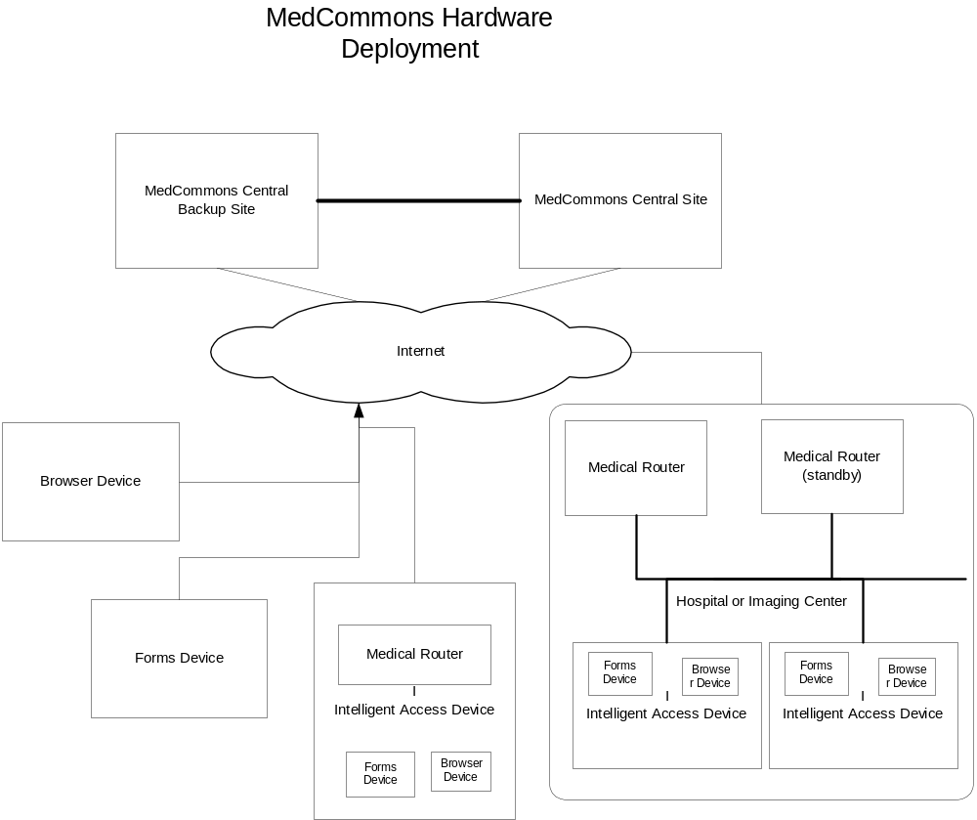

This section pretty much documents all the gear we are planning to field for the SCAR DEMO.
331 MedCommonsCentral The hardware of the initial central system for the demo system is required to be cheap, reliable, and located at our Charlotte colo.
332 MedCommonsCentral Clones of the initial central demo system must be provided to remote developers as necessary, along with a means of periodically obtaining updated software releases.

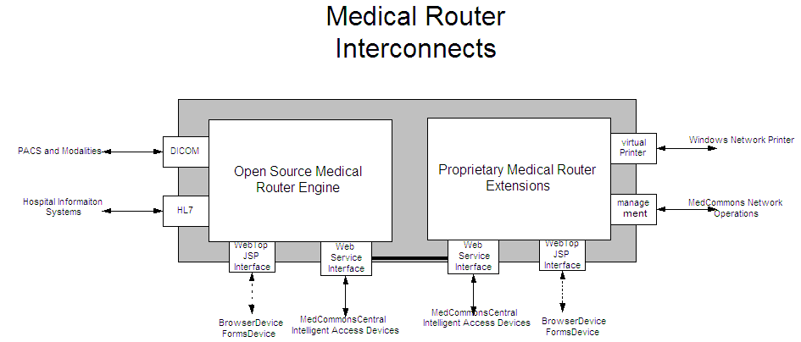

341 MedicalRouter The initial release of the medical router must run as a software component under Windows XP tablet edition as a system service
342 MedicalRouter The medical router must run as software component under a cheap and reliable standalone Linux based system without a physical console.
343 MedicalRouter Tiny Demo Printer (Canon BubbleJet,)
344 Medical Router DICOM Modality simulator -Sends DICOM study in a timed loop;
autogenerates patient names. Also must autogenerate new DICOM *UIDs to avoid database conflict
o To make it look plausible I suggest substituting these
requirements
+ DICOM Modality Simulator sends a study of images in a
timed loop.
+ There are a small number of folders where studies are
read from in a round-robin fashion.
+ The data requirements are:
# At least 4 studies of different parts of the
anatomy. When users in the demo go between
different studies you want them to see the
difference.
# Perhaps MR as well as CT to show a mix of image
types.
# At least 40 images/study; maximum of 200 images
in a study. These are typical real-world sizes
for exams.
# The names may be autogenerated - but we need a
scheme for what this would be. Personally - I'm
opposed to any scheme that looks like "Patient1,
John". I propose that we have a list of names
and PatientIDs in a file that are read in order
- when you hit the end of the file you just
start at the beginning. Maybe we put 20 names
into the file. This way:
* The patient names are sensible and look
'real'.
* Patient names from different sites
(routers) can be put up onto the central
site - we can show multiple studies for
the same patient from different places.
* It's simple.
o The modality simulator has a simple configuration file for
the DICOM parameters (AE title, IP address, port).
o The modality simulator his hidden from view during a demo.
o There needs to be a script which cleans out *all* of the
demo data and database entries to restart the demo.
o code separate from demo..

351 IntelligentAccessDevice Credit Card Swipe (Bill to procure swiper with USB interface)
352 IntelligentAccessDevice Motion Computing Tablet with Wireless Broadband and WiFi
352 IntelligentAccessDevice One or more laptops for demonstrating the Browser and Forms and Intelligent Access Devices distinctly separated from the Tablet. We need to show how the system operates fully without any Tablets at all.

400 MedCommons Central Facilities

For the Demo, all connectivity into the central facility is via Web Services or HTTP(s). It is assumed we are building the site as simply as possible, using J2EE, MySQL, and plain files. We do not anticipate implementing any performance improvements requiring protocol development for the Demo, but we will need to install a special WebDAV/WADO EJB to allow access to stored images over HTTP, and we will also need to implement some servlets to provide ‘Webtop’ access to Browser devices
431 MedCommonsCentral GoToAssist for remote PC Control – Installed and tested, but unmodified. Only one ‘customer support client’ license is needed. Particular attention must be paid to testing support of Tablet users, and to determine whether the customer support person needs a Tablet. GoToAssist can be used by MedCommons to install the IAD software to any computer (e.g: the Clerk's desktop PC) that has Internet access. The only site level configuration is that the Clerk needs to ask the Technologist to add the IAD's Router to the list of DICOM destinations.
432 MedCommonsCentral HIPAA Logs – no search access is required for the Demo, but the logs must be (virtually) segregated per patient. Web Services for programmatic access and a Webtop view must be provided.
433 MedCommonsCentral Stored Studies - Web Services for programmatic access and a Webtop view must be provided

434 MedCommonsCentral Patient Portal provided by the Central Facility - When a Medical Router is installed the Central site automatically provides an immediate capability to run an Internet accessible, firewall friendly, Patient Portal. Out of the box, the Patient Portal puts your hospital logo on the patients' view of MedCommons without any effort on the hospital's part.
435 MedCommonsCentral FAX Receive and Send – FAX Receive will be faked for the DEMO. FAX Send will not be demonstrated.
436 MedCommonsCentral Software Distribution not via Windows Update and must be general enough to accommodate distribution to both Windows and Linux machines
437 MedCommonsCentral Network Management
438 MedCommonsCentral Credit Card Processing Will be faked as always ‘good’

461 MedCommonsCentral WebTop HIPAA WADO Servlet for Router and/or Central System (Sean doing Rev0, Q will work into central database and put the HIPAA bits in) – ensures every access via WebDAV/WADO is tracked in the HIPAA logs. Compresses multiple HIPAA log entries into single entry as appropriate.

500 Content Capture

This section enumerates the various ways that content gets into MedCommons. Our goal is to get as much content into MedCommons Central as possible.

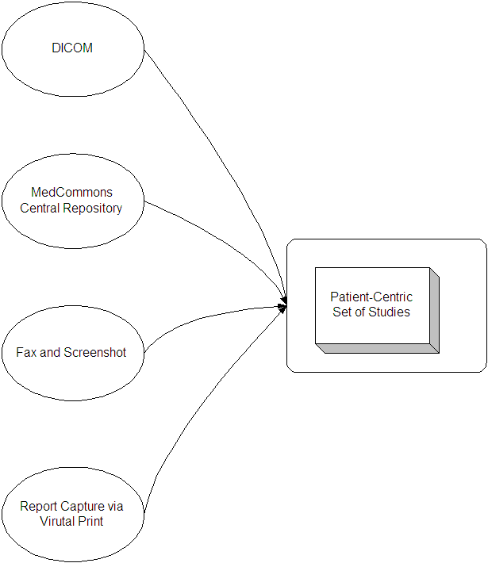
531 Capture Fax Report to MedCommons Central (to Adrian’s eFax who will hand it to Q, which will get stored along with images in studies in) [we need to move to CDA ultimately]
532 Capture Scrape a Web Page (e.g.: Patient’s Portal at Hospital) (for the Demo, we will pre-store patient portal screens as in the fax case, and will display in a frame as discussion topic – for the PTO{PTO?}, we will pursue notion that we provide HIPAA controlled access for physicians into patient portal)
541 Capture HL7 Reports –needs elaboration by Sean , Story needed for SCAR
542 Capture Virtual Print Report to Medical Router – installs Virtual Printer Driver on Windows Devices and Server Component on Medical Router. When User selects ‘Print to MedCommons Router’ the report is buffered on the Medical Router. A separate function permits the clerk to select reports to actually ‘Store in MedCommons’ described in Content Access section. This is "unclean" to the extent that we'd like to keep the Router all OSS. Can be made Kosher by finding an OSS print capture code (Samba?) or by introducing Web Services API to a proprietary package
551 Capture DICOM CD – the Intelligent Access Device blindly copies the contents of a CD via a Web Service to the Medical Router. The Medical Router knows DICOM and intelligently prepares and stores the content in MedCommons Central. Standalone application (may require Java) - not integrated with router or tablet. Could possibly be a signed applet.
o Contains following UI elements
+ Text boxes for router's DICOM config: hostname, port
#, AE title.
+ Navigation controls to file folders (could be CD,
could be other folder in file system). Or - for the
demo we could assume that the CD drive was always "D:"
and bury this in a config file.
+ A button that says 'Send DICOM "
+ Contains progress indicator for send operation.
+ Tells the user when it's done.
+ Reports errors to the user if images are not able to
be transmitted.
o This must be added to the list of screens that need designing.
591 Capture DICOM Push – modalities use DICOM to push studies into the Medical Router. The good news is that code exists in DCM4CHE.
592 Capture DICOM Q/R (both ways) – allows DICOM workstations to get studies from the Medical Router, and for the Medical Router to get studies from PACS devices. The good news is that code exists in DCM4CHE.

600 Content Access and Update

This section enumerates how content on both the MedCommons Central Facilities and the Medical Router is accessed by Intelligent Access Devices, Browser Devices, and 3rd Party Workstations. Note that Forms Devices are used primarily for registration and commerce, and as such are not detailed here.

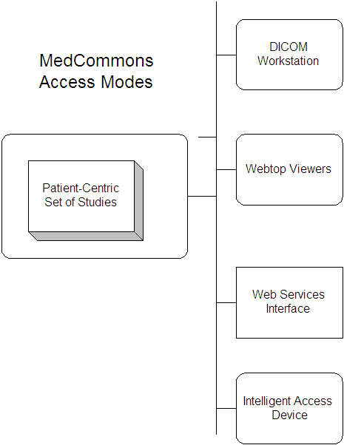
651 IntelligentAccessDevice View FullSize Images via WADO viewer invokes the WebTop Study viewer as an IE control in a fixed window. Over time this function may be replaced with a custom viewer built specifically for the Intelligent Access Device.
652 IntelligentAccessDevice View Thumbnails via Thumbnail viewer invokes the WebTop Thumbnail viewer as an IE control in a fixed window. Over time this function may be replaced with a custom viewer built specifically for the Intelligent Access Device.
653 IntelligentAccessDevice View Report allows clerk at Intelligent Access Device to access a Report from MedCommons Central or a local Medical Router. For the DEMO Reports are canned and stored in Patient’s Folder at MedCommons Central.
654 IntelligentAccessDevice DICOM Q/R from PACS allows clerk at an Intelligent Access Device to view a list of studies. It is implemented as a web service call to the Medical Router, which in turn makes DICOM calls to access a local PACS. In a future release this function can also access the MedCommons central System.

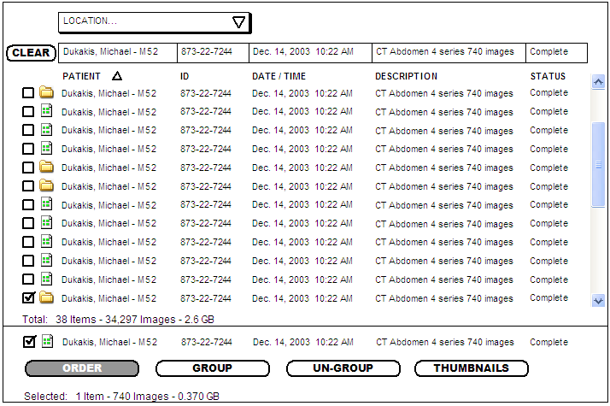

655 Intelligent Access Device - Selection Screen -is the default display for any user logged in to the IAD as a Clerk.

656 Intelligent Access Device – Selection Screen to FormsDevice Navigation – user can seamlessly move from and Order Form to the Selection Screen and vice versa, with appropriate contextual field filling as required.

657 Intelligent Access Device – Selection Screen Behaviors - The Found List (with scrollbar below) updates continuously as the number of images changed. By default, the Search Criteria (thin border boxes on line 2) is empty (also CLEAR|button action) and the most recent Study is sorted to the bottom of the Found List (with checkmark). The last item on the Found List is duplicated below the Separator Line and becomes the default Order Form entry.
- The Location drop menu is restricted to places that the user has the privilege to see. A patient, would see only their own (or their family's) studies.
- Typing into any Search Criteria would automatically filter the Found List. Wild Cards and Date Ranges are not required for the Demo. The Clear button blanks all Search Criteria resulting in the display of all items in the Location. It would be nice for the Date Criterion to default to Today so that the list would not become too huge.
- The third row has labels and allows the user to sort (see arrow).
- List Items can be either Studies or Groups of Studies called Folders. Under special circumstances, multiple Patients can be put into a single Folder but this is not required for the Demo. The only Status required for the Demo is Complete and Processing.
- The Total for line items on the Found List should include the total of items selected (not shown) It should be possible to sort for the Selected items..
- The "line" separates the items found from the items that will become the Order's payload. This line moves up and down automatically as items are checked and unchecked. either above or below.
- The Order Button, brings up the default Order Form for that facility. The Demo need not support more than one Order Form per facility.
  - The Group Button collapses all of the items below the line into a Folder. The user is prompted to name Folder in a dialog box and the Folder is added to the Found List above the line with today's date. The items within the folder are left on the Found Items list but their checkmarks are removed. In other words, a Group command creates a new item on the particular Location archive. For the Demo, Folder contents are actually copied.
  - The Un-group button is only active if there's a folder below the line and the user has clicked on that folder. The Un-Group action reverses the action of the Group action. There is no deletion or editing functionality required for the demo.
  - Clicking Thumbnails brings up a window showing all Series referenced below the line. This means that one thumbnail is shown for each series with no regard for Folder membership. The Thumbnail should typically be the middle image of the series. Each Thumbnail should be labeled with a single line title, the total number of images in the series, associated with a selection checkbox that can be used to remove it from the pending order. Removing a Series from a pending Order does not erase a series from the corresponding Study or Folder. A magnifier or link to the simple viewer should make it easy to show full size sub-regions of the thumbnail's image for quality control purposes.
  - The Selected summary basically tells you how big a transfer the Order will cause.
  - The Selection Screen will update roughly every second. This will make
it easier to return the results of DICOM Q/R and will make the whole
system feel more responsive.
  - To make multiple selection possible, updates to the Selection Screen
will stop automatically when the mouse is clicked almost anywhere in the
window. A Lock Icon will be displayed. Updates will resume when the lock
is clicked or automatically after a time-out.
  - The items in the Location dropdown at the top of the Selection Screen
will reflect the role of the user as logged into Windows.
  - If a Query is too broad and returns more than 100 studies, the Totals
will be updated but the study information need not actually be
transferred across the WS interface
661 CentralWebTop HIPAA Log from Central Facilities (Q, and with Web View patient centric, no searching, sorted by time)
662 CentralWebtop Selection Screen - this function allows a clerk (either at the MedCommons Central Call Center or at a Hospital/Imaging Center to choose studies cross patients and permits dispatches to other viewers. Has similar but reduced capabilities to the Intelligent Access Device Selection Screen. (not a Demo requirement). severely limit the ability for us to demo how a Patient (not the Clerk) can control their own image dispositions. This needs a bit more thought to determine how important it is to show central patient control given that it does not pass the grandmother test.

Base 1A | Grandma calls MedCommons on phone, gives secret SSN and passcodes and a MedCommons Associate open’s Grandma’s account as is shown a list of studies like the Selection Screen 665
Or Base 1B | Grandson logs in to Grandma’s or Family Account at MedCommons Central and is shown a list of studies…
Click 1 | A study is clicked that opens an OrdersForm on the associated FormsDevice
DataEntry 1 | The Second opinion Physician's Name and an email address or Fax number are added to the Order Form. The payload is verified (Thumnails might be opened here). The payment precondition for ordering must also be satisfied (see Commerce)
Receive Tracking Receipt | After completion of the Ordering Process either Grandson or MedCommons Clerk can fax or email the Tracking Number to the physician and/or patient, or the patient can request a hardcopy printout of a receipt with the Tracking Number displayed.
Associate with Physician | If the Physician has an account at MedCommons, Grandma's Study is added to the Physician's Webtop Selection Screen 662.

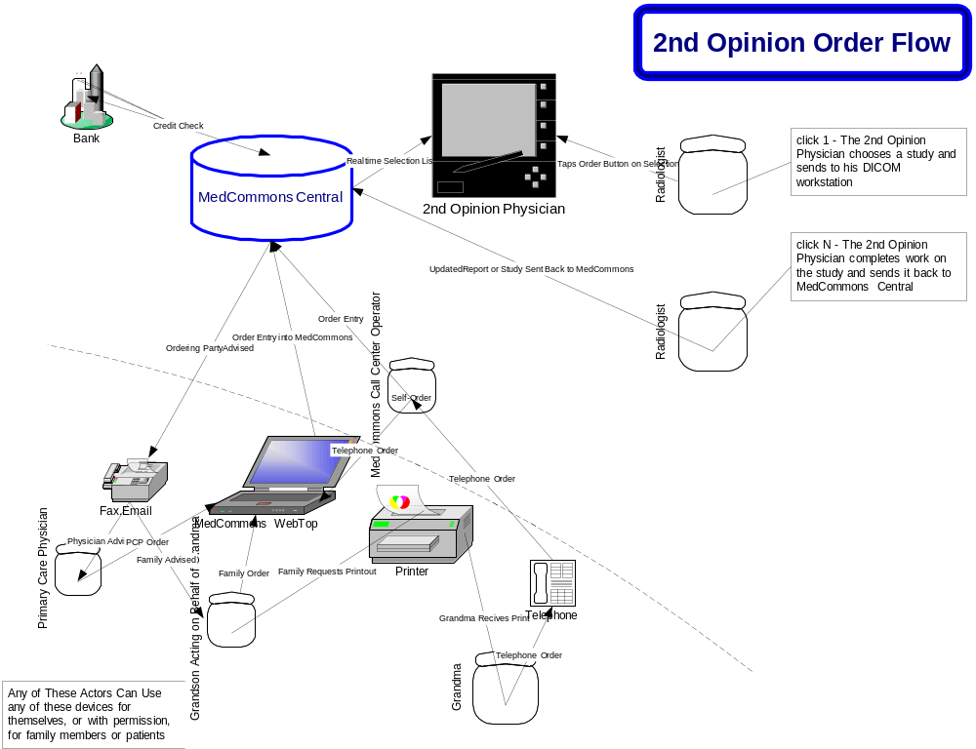
671 RouterWebTop Study Viewer for Patients and Primary Care Physicians – shows jpegs and allows navigation. This version will be ‘butt ugly –Sean’, but be useful for Macs, and generic browsers. Built using WADO, and is zero-install.
672 RouterWebTop Thumbnail Viewer for Patients and Primary Care Physicians– shows thumbnails and allows navigation. This version will be ‘butt ugly –Sean’, but be useful for Macs, and generic browsers, and will be invoked as a pop-up in various contexts by the user interfaces. Built using WADO, and is zero-install.
673 RouterWebTop Send to Physician – allows patients to select content and send to her physician, or for second opinion. Zero – install. Needs matching central system capabilities.
691 DicomWkstn View Study – a 3rd Party Workstation uses DICOM to access the Medical Router and obtain a study, either from the router itself, or via proxy thru a web service interface to the central medcommons site.
692 DicomWkstn Update Study to MedCommons Patient’s Account – 3rd Party Workstation can update a Study and store it back to the patient account via proxy thru the Medical Router.
693 DicomWkstn Add Series to Study on PACS – this is a complex function based on the Round Trip Checkbox on the Capture Order Form. This is a reverse flow from medical router A thru MedCommons Central into a different medical router B and then into a PACS machine – needs more elaboration.

700 Administration and Registration

To the greatest extent possible the system is self – administered by patients and clerks. As a last resort, or for customers who are completely unable to utilize the system, clerks at MedCommons Central can administer the system via WebTop functions or can even use GoToAssist to take control of the users Windows PC.
751 Admin Clerks at hospital and imaging centers utilize a thick Windows specific program on the Intelligent Access Device.
752 IntelligentAccessDevice Group / Merge / Split Interface (later) allows a clerk to associate different study objects with particular patients. Grouping of studies will always make a copy. The Thumbnails view may be used to edit the contents of a Group by removing individual Series. Newly formed Groups will be updated at the Central Facility ASAP. In the future, watermarks and/or separate passwords may be applied to a Group but this is not a Demo requirement
753 IntelligentAccessDevice Send Virtual Printout to MedCommons allows a clerk to choose a Report previously stored on a Medical Router and send it to a particular patient’s folder on MedCommons.
754 IntelligentAccessDevice Send Screen Scrape to MedCommons allows a clerk to choose a Screen Scrape previously stored in the Screen Scrape Cache and send it to a particular patient’s folder on MedCommons.
755 IntelligentAccessDevice The Intelligent Access Device supports Login Authentication and Authorization (Browsing Scope) (standard windows stuff for now)
756 IntelligentAccessDevice Signature Tablet – use OneNote or small app to capture signature as TIFF and use Web Services (via router proxy) to store in central system
757 IntelligentAccessDevice The Intelligent Access Device supports direct Logout as a menu choice, and via a pop=up dialog if the main window is closed by the User. An inactivity timeout can also be set as a preference by the user, enabling automated logout after N minutes of inattention.
761 Admin Patients administer their accounts via WebTop functions. For the DEMO this will be read-only, with some hyperlinks to demonstrate navigation.
762 Admin MedCommons Clerks utilize WebTop functions.
763 CentralWebTop WebTop Account Creation (one-time per family) – allows an account to be created for a patient. Card Association, email invoices and notifications
764 CentralWebTop WebTop Physician Account Creation- Account Features beyond “Patient” TBD
765 CentralWebtop Central Facilities Patient Account Administration (needs to show dichotomy of private vs clerk-modifiable)

Registration will be faked for the Demo, but will be ultimately supported as Central Webtop functions. We will need to preload various patients and physicians into central system, as well as pre-register all the devices
766 CentralWebTop Nodes Client Registration (need to get these in here)
766 CentralWebTop PACS Registration (AETitles, etc)
767 CentralWebTop Thick Client Registration
771 RouterWebTop Burn CD (must be available under Windows, not needed for DEMO)

800 Commerce

This is the heart of the system. As various context specific order forms are filled in and accepted, they are queued for processing by the system. The Order Forms must be digitally signed, and form a perfect audit trail. The system does whatever the Order Forms specify. The forms may be filled by tablet or keyboard, or via paper forms via scanner or fax, as provided by the Forms System.

801 Commerce System is driven by a system of order forms, which must be filled in properly and signed by an appropriately authorized user before any actions involving patient information are taken.
802 Commerce System is indifferent to whether forms are prepared and submitted electronically or on paper. The system must support input via keyboard, tablet, fax, and scanner, and allow signatures via tablet, fax or scanner, without prejudice.
803 Commerce System Orders may optionally encompass a list of studies, or subsets of studies. The only means to manipulate a study by a user other than a
MedCommons customer care operator is to submit an Order Form via a Forms
Device.
805 Commerce System All Order Forms are received and processed directly by MedCommons Central. The Forms Device will be asynchronously informed of successful
processing of the order form and will present this status on a realtime display list. The user may also choose to be notified of status via an email alert. As the order is handled in subsequent stages of the workflow between medcommons, and the various actors, the same alerting mechanism would be used to inform progress and to generate a final Report
806 Commerce Systeml If MedCommons Central and its backup are unreachable for any reason,the Forms Device will store a (partially) completed form internally until
such a time as when MedCommons Central is again available when the form will
be re-submitted
These requirements specify the preconditions necessary to get MedCommons to ‘do something’
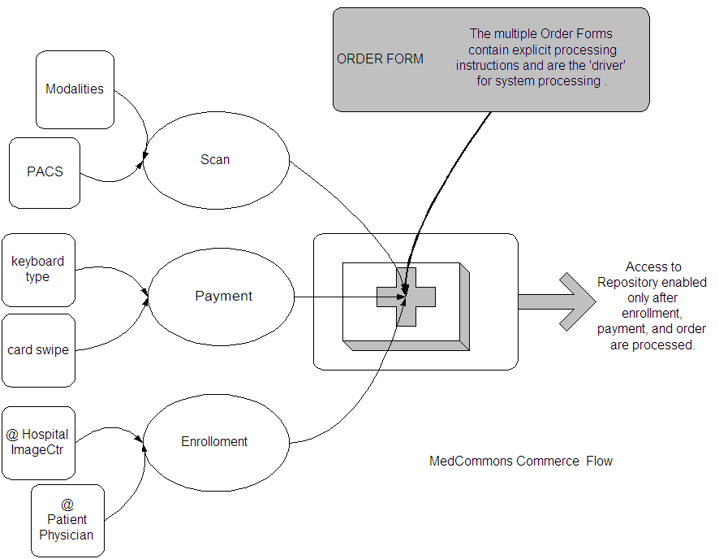

821 MedCommons Central – Before any content is released from MedCommons Central, the Patient must be properly enrolled in MedCommons. If a patient is scanned before he is enrolled, the content will be held by MedCommons central for a reasonable time period.
822 MedCommons Central – Before any content is released from MedCommons Central, payment must have been made by the Patient.
823 MedCommons Central – Before any content is released from MedCommons Central, the content must have been identified and migrated from Medical Routers into MedCommons Central.
824 MedCommons Central – Before any content is released from MedCommons Central, a properly signed Order Form must have been received by MedCommons Central.
825 MedCommons Central - MedCommons will process an order only after all of the pre-conditions noted in 821-824 are satisfied
826 Commerce System Access to different Order Forms will be restricted based upon a
user's role within the system.
831 MedCommons Central - Customers who are scanned at an imagining center when MedCommons Central is unavailable will be given a receipt with a local tracking number
which will be used as an additional key into the order for future problem resolution.
832 MedCommons Central All Orders, whether successfully entered or not, generate a Response Form which is delivered back to the originating user. An incorrect
order would contain details on the nature of the problem and the fields in
error. A user at the Forms Device can correct this form and resubmit. A
successfully entered order would be the original order form, signed by
MedCommons, and with a GUID and transaction number, etc.
841 Medical Router If a particular order needs to involve a medical router specifically,
then MedCommonsCentral will inform that router as and when necessary and
will audit and track the behavior of the medical router in a HIPAA compliant
manner
These requirements discuss the nature of the FormsDevice as required by MedCommons
881 FormsDevice Persistence of User Context Automatically assumes the last received DICOM Study and other variables.
881 FormsDevice Signing Mechanism – the forms device has a mechanism for digitally signing forms. This will be used by both patients and phsycians.
882 FormsDevice Printing Mechanism – the forms device has a means for obtaining high quality prints of forms that can later be used as scanned or faxed input to the system.
883 FormsDevice Scan Mechanism – the forms device can be emulated by a scanner or fax machine and software when processing paper forms generated by the Print Mechanism In practice this will mean MedCommons call center operators messing about will real mail via scanners, and incoming faxes via a fax server of sorts (not for demo)
884 FormsDevice Form Fill and Processing There will be multiple re-brandable forms types, depending on context. Completion of the form (including signing, card swiping, and other specialized fields) will trigger a Web Service call into MedCommons Central.
885 FormsDevice Credit Card ID and Processing – If the optional Credit Card Swipe is used, the IAD will read the stripe and utilize the associated ID. If no card swipe is present, or if the user prefers the Card ID and associated security (3 or 4 digit code) can be entered from a keyboard. The IAD will call MedCommons Central to identify the user and return additional user preferences including email, address, physician, etc. At this point it has not debited the card, which only happens when the user takes a determinate action.
886 FormsDevice Browser Linking Mechanism – The FormsDevice supports the standard use of embedded hyperlinks in supported forms. The standard action taken on a hyperlink is to invoke a WebTop function in a separate Browser window. It would be good to select a mechanism for passing information from Browser windows back into the forms.
887 FormsDevice Customization via JavaScript and WebServices integration to external services which can return data for validation of form fields and integration as additional form data.

Herein follows a sample Order Form. There will be different variants, depending on what sort of transaction the patient, physician, or clerk wants to perform
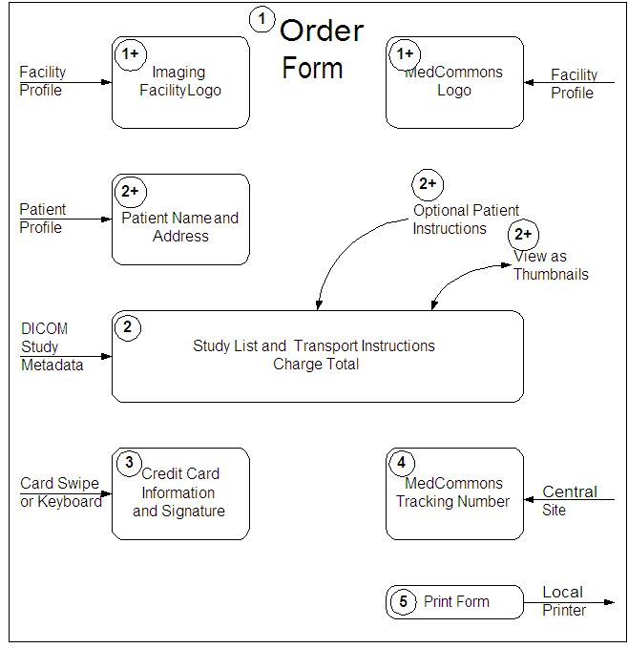
- A MedCommons transaction begins when form is selected by a clerk responding to a Patient's request. The form automatically fills in with logos and fields representing the information implied by the requested transaction.
- The IAD attempts to guess the contents of the Study List based on recent activity such as credit card swipe, recent DICOM traffic to the Medical Router, or the Clerk's selection on a Selection Screen in Step 1 above. If the guess is inappropriate, the Clerk can, invoke the Selection Screen via an embedded hyperlink, click checkboxes that reflect optional patient instructuions and can evaluate the payload of the pending transaction on a Thumbnail Screen. The amount to be charged reflects the pending transaction.
- The Patient's acceptance of the charge (by clicking on a credit card terminal or the screen) also indicates the intent to transfer HIPAA responsibility from the Imaging Facility to MedCommons.
- MedCommons issues a Tracking Number to confirm acceptance of HIPAA responsibility and begins the capture and transmission of the payload to the Central Facility.
- The Clerk prints and delivers a copy of the Order Form to the Patient. It is assumed that the patient will lose their copy of the order form most of the time. If the patient profile or optional patient instructions included an email, physician email, or enough information for the payload to be added to the Patient's account at MedCommons, then this is not a problem. If the Order Form had just the credit card info along with the payload, and the patient loses the tracking number, then the patient will have to contact either the imaging facility or MedCommons for help in registering a Patient Profile and extracting their study from MedCommons quarantine.
- Round Trip Checkbox – if checked then studies that are sent outside the enterprise for 2nd opinions, etc, will come back here
- Destination Physician – optional
- Patient History or Comments as Free Text – after the DEMO we will move to capture as Ink.
Note that this sequence is for the case of an order created
*after* the study has been aquired. We'll need a separate (perhaps
post-demo) case for getting the order before the study is acquired.

900 Security
901 Security HIPAA – all MedCommons personnel with access to Protected Health Information (PHI) - (including developers and call center operators) are subject to HIPAA rules including training and no shared passwords. Databases and Profile directories are PHI whether or not they are not archived as 21CFR11 content.
902 Security Internet Communications – all are encrypted using SSL or equivalent. All transmissions encrypted between mc central and medical router, preferably using SSL (not for demo)
903 Security Password complexity will be checked (e.g., size of password, special
characters). [Not Demo]
904 Security MedCommons will operate against formally written operating
and security procedures.[Simplified version for Demo]
905 Security Registration of providers (e.g., primary care physician) requires
third party review of credentials prior to bootstrapping them into the system.
906 Security Digital signatures of documents will have process mechanisms to make
signatures legally binding.[Not Demo]
907 Security Integratity checks of user data will be automatically performed by MediCommons on a Periodic basis.
921 Security User Privileges – Selection Screen (browsing) privilege is only available to specified users
922 All user interface devices (forms, browser, IAD) require password verification to “release” secret keys and other private informationon the device (not in Demo)
- Encrypt_{key = password} (private_info | Hash (private_info | password))
- Encrypt_{key = password} (private_info)), Hash (private_info | password))
- encrypt and authenticate using XML encryption/signatures.
923 All user interface devices will time-out and “reject” private keys afer a period of non-user (20 minutes, not in Demo)

.
931 Security HIPAA Logs – The MedCommons Central system must record user name from signed forms along with transaction ID.
932 Security Central Facilities – Forms, HIPAA Logs and Patient Records (e.g.: DICOM, Reports) are archived to 21CFR11 standard.
933 MedCommonsCentral Intrusion Detection –
934 MedCommons Central Physical Security –
935 MedCommons Central facility will be protected behind firewall.
[Simplified version for demo]
936 Security MedCommons Central Unencrypted content delivery to Medical Routerswrites HIPAA log entry on MedCommons central at time of successful transmission (not for demo)
937 Encrypted delivery requires notification to MedCommons central to make
HIPAA(Isthis 1 ws call or 2?) log entry at time of actual content access by a specific doctor.
938 MedCommons Central will maintain Admin and User access logs. [Not Demo]
939 MedCommons Central will store medical information using one of its
private encryption keys. And only one key, not one per patient.
[Not for Demo]
941 Medical Router Headless System – Router must run totally in the background without need for permanently logged in user interface, An Admin interface will be provided for which Administratorsof device must authenticate to device when accessing by either the local network or Internet. [Not for Demo]
942 Medical Router Remote Control – needs strong authentication and PKI

943 Security Medical Router As specified in an Order (or defaulted or via a customer preference), Content can be delivered into a remote router: (not for demo)
1) Encrypted by private key of that router (default case)
2) Encrypted for a doctor or group of doctors
3) Unencrypted (for free-for all DICOM access by PACS, 3DWkstn) - MGH
944 Security Medical Routers will maintain logs of documents sent and received for
XX days. [not Demo]
945 Security Medical router logs will not reveal patient Information.
[Not Demo]
946 Security Medical Routers will maintain a log of admin access.
[Not Demo]
951 Security If a tablet is handed to a patient, it will not display a Selection Screen and the Windows login will be assumed to be as Guest.
981 Security Forms Signing – based on separate challenge (Acrobat digital signature or equivalent) for selected forms. Forms can be signed even with Guest login so that patients can sign a form on the IAD. - The signing of the Order Form will use a separate mechanism that may or may not be related to the user's Windows login.
982 Security Digital Signatures – The creation of digital credentials (e.g.: Acrobat) does not have to part of the demo.

1000 Cross References to Requirements by Actor

This section duplicates most requirements from the main document, but organizes them by Actor. Do not introduce new requirements in this section

1200 Requirements Applicable to User Behavior
821 MedCommons Central – Before any content is released from MedCommons Central, the Patient must be properly enrolled in MedCommons. If a patient is scanned before he is enrolled, the content will be held by MedCommons central for a reasonable time period.
822 MedCommons Central – Before any content is released from MedCommons Central, payment must have been made by the Patient.
823 MedCommons Central – Before any content is released from MedCommons Central, the content must have been identified and migrated from Medical Routers into MedCommons Central.
824 MedCommons Central – Before any content is released from MedCommons Central, a properly signed Order Form must have been received by MedCommons Central.
825 MedCommons Central - MedCommons will process an order only after all of the pre-conditions noted in 821-824 are satisfied
921 Security User Privileges – Selection Screen (browsing) privilege is only available to specified users
922 All user interface devices (forms, browser, IAD) require password verification to “release” secret keys and other private informationon the device (not in Demo)
- Encrypt_{key = password} (private_info | Hash (private_info | password))
- Encrypt_{key = password} (private_info)), Hash (private_info | password))
- encrypt and authenticate using XML encryption/signatures.
923 All user interface devices will time-out and “reject” private keys afer a period of non-user (20 minutes, not in Demo)

1300 Requirements Applicable to the Central System
231 Arch The Central Facility must, over time, scale indefinitely to accommodate additional content types and users.
331 MedCommonsCentral The hardware of the initial central system for the demo system is required to be cheap, reliable, and located at our Charlotte colo.
332 MedCommonsCentral Clones of the initial central demo system must be provided to remote developers as necessary, along with a means of periodically obtaining updated software releases.
431 MedCommonsCentral GoToAssist for remote PC Control – Installed and tested, but unmodified. Only one ‘customer support client’ license is needed. Particular attention must be paid to testing support of Tablet users, and to determine whether the customer support person needs a Tablet.
432 MedCommonsCentral HIPAA Logs – no search access is required for the Demo, but the logs must be (virtually) segregated per patient. Web Services for programmatic access and a Webtop view must be provided.
433 MedCommonsCentral Stored Studies - Web Services for programmatic access and a Webtop view must be provided

434 MedCommonsCentral Patient Portal provided by the Central Facility - When a Medical Router is installed the Central site automatically provides an immediate capability to run an Internet accessible, firewall friendly, Patient Portal. Out of the box, the Patient Portal puts your hospital logo on the patients' view of MedCommons without any effort on the hospital's part.

435 MedCommonsCentral FAX Receive and Send – FAX Receive will be faked for the DEMO. FAX Send will not be demonstrated.
436 MedCommonsCentral Software Distribution not via Windows Update and must be general enough to accommodate distribution to both Windows and Linux machines
437 MedCommonsCentral Network Management
438 MedCommonsCentral Credit Card Processing Will be faked as always ‘good’
531 Capture Fax Report to MedCommons Central (to Adrian’s eFax who will hand it to Q, which will get stored along with images in studies in) [we need to move to CDA ultimately]
532 Capture Scrape a Web Page (e.g.: Patient’s Portal at Hospital) (for the Demo, we will pre-store patient portal screens as in the fax case, and will display in a frame as discussion topic – for the PTO{PTO?}, we will pursue notion that we provide HIPAA controlled access for physicians into patient portal)
831 MedCommons Central - Customers who are scanned at an imagining center when MedCommons Central is unavailable will be given a receipt with a local tracking number
which will be used as an additional key into the order for future problem resolution.
832 MedCommons Central All Orders, whether successfully entered or not, generate a Response Form which is delivered back to the originating user. An incorrect
order would contain details on the nature of the problem and the fields in
error. A user at the Forms Device can correct this form and resubmit. A
successfully entered order would be the original order form, signed by
MedCommons, and with a GUID and transaction number, etc.
931 Security HIPAA Logs – The MedCommons Central system must record user name from signed forms along with transaction ID.
932 Security Central Facilities – Forms, HIPAA Logs and Patient Records (e.g.: DICOM, Reports) are archived to 21CFR11 standard.
933 MedCommonsCentral Intrusion Detection –
935 MedCommons Central facility will be protected behind firewall.
[Simplified version for demo]
936 Security MedCommons Central Unencrypted content delivery to Medical Routerswrites HIPAA log entry on MedCommons central at time of successful transmission (not for demo)
937 Encrypted delivery requires notification to MedCommons central to make
HIPAA(Isthis 1 ws call or 2?) log entry at time of actual content access by a specific doctor.
938 MedCommons Central will maintain Admin and User access logs. [Not Demo]
939 MedCommons Central will store medical information using one of its
private encryption keys. And only one key, not one per patient.
[Not for Demo]

1400 Requirements Applicable to the Medical Routers
241 Arch The Medical Routers act as a web service client to the Central Facilities and as a web service provider to the Intelligent Access Devices.
242 Arch The Medical Routers must scale within a single enterprise by adding additional cpu and disk capacity, but it is not necessary to provide unlimited scaling.
243 Arch Backup Medical Routers must be installable within a single enterprise to support to provide backup capability for each other
341 MedicalRouter The initial release of the medical router must run as a software component under Windows XP tablet edition as a system service.
342 MedicalRouter The medical router must run as software component under a cheap and reliable standalone Linux based system without a physical console.
343 MedicalRouter Tiny Demo Printer (Canon BubbleJet,)
344 MedicalRouter Tiny Hub (optional ?)
541 Capture HL7 Reports –needs elaboration by Sean , Story needed for SCAR
542 Capture Virtual Print Report to Medical Router – installs Virtual Printer Driver on Windows Devices and Server Component on Medical Router. When User selects ‘Print to MedCommons Router’ the report is buffered on the Medical Router. A separate function permits the clerk to select reports to actually ‘Store in MedCommons’ described in Content Access section.
841 Medical Router If a particular order needs to involve a medical router specifically,
then MedCommonsCentral will inform that router as and when necessary and
will audit and track the behavior of the medical router in a HIPAA compliant
manner
941 Medical Router Headless System – Router must run totally in the background without need for permanently logged in user interface, An Admin interface will be provided for which Administratorsof device must authenticate to device when accessing by either the local network or Internet. [Not for Demo]

943 Security Medical Router As specified in an Order (or defaulted or via a customer preference), Content can be delivered into a remote router: (not for demo)
1) Encrypted by private key of that router (default case)
2) Encrypted for a doctor or group of doctors
3) Unencrypted (for free-for all DICOM access by PACS, 3DWkstn) - MGH
944 Security Medical Routers will maintain logs of documents sent and received for
XX days. [not Demo]
945 Security Medical router logs will not reveal patient Information.
[Not Demo]
946 Security Medical Routers will maintain a log of admin access.
[Not Demo]

1500 Requirements Applicable to Intelligent Access Devices
251 Arch The Intelligent Access Devices Connect as a web service client only to Medical Routers. Access to the Central Facilities by Intelligent Access Devices must be ‘proxied’ through a Medical Router, even if the router is embedded in the Intelligent Access Device.
252 Arch The Intelligent Access Device must be capable of serially connecting to multiple Medical Routers within the same enterprise.
253 Arch The Medical Router and Intelligent Access Device must be capable of co-existing in the same hardware device. Practically speaking this means the router code must also run under XP and must be tight enough to run politely without damaging the user experience. This is the configuration that will be fielded for the demo
254 Arch The firewall differences between hospitals and home will be accommodated so that IADs, as embodied in Windows Tablets, will be designed so that if they are taken home by a doctor they will continue to work as expected. In the hospital, the Tablet might connect to a separate Hospital DICOM router(HR) whereas at home the embedded DICOM router in the Tablet will connect directly to MedCommons.
255 Arch The Intelligent Access Device must support the Browser Device and Forms Device within the same hardware platform, and with a deep degree of integration. In practice this means the Windows program must run some functions under the IE active/x controls and supply URLs, etc to avoid redundant user input, etc. It is especially important that users not have to log in multiple times.
351 IntelligentAccessDevice Credit Card Swipe (Bill to procure swiper with USB interface)
352 IntelligentAccessDevice Motion Computing Tablet with Wireless Broadband and WiFi
352 IntelligentAccessDevice One or more laptops for demonstrating the Browser and Forms and Intelligent Access Devices distinctly separated from the Tablet. We need to show how the system operates fully without any Tablets at all.
551 Capture DICOM CD – the Intelligent Access Device blindly copies the contents of a CD via a Web Service to the Medical Router. The Medical Router knows DICOM and intelligently prepares and stores the content in MedCommons Central
651 IntelligentAccessDevice View FullSize Images via WADO viewer invokes the WebTop Study viewer as an IE control in a fixed window. Over time this function may be replaced with a bespoke viewer built specifically for the Intelligent Access Device.
652 IntelligentAccessDevice View Thumbnails via Thumbnail viewer invokes the WebTop Thumbnail viewer as an IE control in a fixed window. Over time this function may be replaced with a bespoke viewer built specifically for the Intelligent Access Device.
653 IntelligentAccessDevice View Report allows clerk at Intelligent Access Device to access a Report from MedCommons Central or a local Medical Router. For the DEMO Reports are canned and stored in Patient’s Folder at MedCommons Central.
654 IntelligentAccessDevice DICOM Q/R from PACS allows clerk at an Intelligent Access Device to view a list of studies. It is implemented as a web service call to the Medical Router, which in turn makes DICOM calls to access a local PACS. In a future release this function can also access the MedCommons central System.
655 Intelligent Access Device - Selection Screen -is the default display for any user logged in to the IAD as a Clerk.

656 Intelligent Access Device – Selection Screen to FormsDevice Navigation – user can seamlessly move from and Order Form to the Selection Screen and vice versa, with appropriate contextual field filling as required.
657 Intelligent Access Device – Selection Screen Behaviors –
751 Admin Clerks at hospital and imaging centers utilize a thick Windows specific program on the Intelligent Access Device.
752 IntelligentAccessDevice Group / Merge / Split Interface (later) allows a clerk to associate different study objects with particular patients. Grouping of studies will always make a copy. The Thumbnails view may be used to edit the contents of a Group by removing individual Series. Newly formed Groups will be updated at the Central Facility ASAP. In the future, watermarks and/or separate passwords may be applied to a Group but this is not a Demo requirement
753 IntelligentAccessDevice Send Virtual Printout to MedCommons allows a clerk to choose a Report previously stored on a Medical Router and send it to a particular patient’s folder on MedCommons.
754 IntelligentAccessDevice Send Screen Scrape to MedCommons allows a clerk to choose a Screen Scrape previously stored in the Screen Scrape Cache and send it to a particular patient’s folder on MedCommons.
755 IntelligentAccessDevice The Intelligent Access Device supports Login Authentication and Authorization (Browsing Scope) (standard windows stuff for now)
756 IntelligentAccessDevice Signature Tablet – use OneNote or small app to capture signature as TIFF and use Web Services (via router proxy) to store in central system
757 IntelligentAccessDevice The Intelligent Access Device supports direct Logout as a menu choice, and via a pop=up dialog if the main window is closed by the User. An inactivity timeout can also be set as a preference by the user, enabling automated logout after N minutes of inattention.
951 Security If a tablet is handed to a patient, it will not display a Selection Screen and the Windows login will be assumed to be as Guest.

1600 Requirements Applicable to Central Webtop Browser Functions
461 MedCommonsCentral WebTop HIPAA WADO Servlet for Router and/or Central System (Sean doing Rev0, Q will work into central database and put the HIPAA bits in) – ensures every access via WebDAV/WADO is tracked in the HIPAA logs. Compresses multiple HIPAA log entries into single entry as appropriate.
661 CentralWebTop HIPAA Log from Central Facilities (Q, and with Web View patient centric, no searching, sorted by time)
662 CentralWebtop Selection Screen - this function allows a clerk (either at the MedCommons Central Call Center or at a Hospital/Imaging Center to choose studies
761 Admin Patients administer their accounts via WebTop functions. For the DEMO this will be read-only, with some hyperlinks to demonstrate navigation.
762 Admin MedCommons Clerks utilize WebTop functions.
763 CentralWebTop WebTop Account Creation (one-time per family) – allows an account to be created for a patient. Card Association, email invoices and notifications
764 CentralWebTop WebTop Physician Account Creation- Account Features beyond “Patient” TBD
765 CentralWebtop Central Facilities Patient Account Administration (needs to show dichotomy of private vs clerk-modifiable)
766 CentralWebTop Nodes Client Registration (need to get these in here)
766 CentralWebTop PACS Registration (AETitles, etc)
767 CentralWebTop Thick Client Registration

1700 Requirements Applicable to Router Webtop Browser Functions
271 Arch The Browser Devices connect to Medical Routers and the Central Facilities via standard Internet HTTP(s) protocols and their variants. The Medical Routers and Central Facilities must be capable of producing standard HTML Web Pages containing dynamically assembled content..
671 RouterWebTop Study Viewer for Patients and Primary Care Physicians – shows jpegs and allows navigation. This version will be ‘butt ugly –Sean’, but be useful for Macs, and generic browsers. Built using WADO, and is zero-install.
672 RouterWebTop Thumbnail Viewer for Patients and Primary Care Physicians– shows thumbnails and allows navigation. This version will be ‘butt ugly –Sean’, but be useful for Macs, and generic browsers, and will be invoked as a pop-up in various contexts by the user interfaces. Built using WADO, and is zero-install.
673 RouterWebTop Send to Physician – allows patients to select content and send to her physician, or for second opinion. Zero – install. Needs matching central system capabilities.
771 RouterWebTop Burn CD (must be available under Windows, not needed for DEMO)

1800 Requirements Applicable to Forms Devices
281 Arch The Forms Devices operate locally with regards to the user interface, field fill-in and validation, and issue web service client calls as necessary to Medical Routers and the Central Facilities.
826 Commerce System Access to different Order Forms will be restricted based upon a
user's role within the system.
881 FormsDevice Persistence of User Context Automatically assumes the last received DICOM Study and other variables.
881 FormsDevice Signing Mechanism – the forms device has a mechanism for digitally signing forms. This will be used by both patients and phsycians.
882 FormsDevice Printing Mechanism – the forms device has a means for obtaining high quality prints of forms that can later be used as scanned or faxed input to the system.
883 FormsDevice Scan Mechanism – the forms device can be emulated by a scanner or fax machine and software when processing paper forms generated by the Print Mechanism In practice this will mean MedCommons call center operators messing about will real mail via scanners, and incoming faxes via a fax server of sorts (not for demo)
884 FormsDevice Form Fill and Processing There will be multiple re-brandable forms types, depending on context. Completion of the form (including signing, card swiping, and other specialized fields) will trigger a Web Service call into MedCommons Central.
885 FormsDevice Credit Card ID and Processing – If the optional Credit Card Swipe is used, the IAD will read the stripe and utilize the associated ID. If no card swipe is present, or if the user prefers the Card ID and associated security (3 or 4 digit code) can be entered from a keyboard. The IAD will call MedCommons Central to identify the user and return additional user preferences including email, address, physician, etc. At this point it has not debited the card, which only happens when the user takes a determinate action.
886 FormsDevice Browser Linking Mechanism – The FormsDevice supports the standard use of embedded hyperlinks in supported forms. The standard action taken on a hyperlink is to invoke a WebTop function in a separate Browser window. It would be good to select a mechanism for passing information from Browser windows back into the forms.
887 FormsDevice Customization via JavaScript and WebServices integration to external services which can return data for validation of form fields and integration as additional form data.
981 Security Forms Signing – based on separate challenge (Acrobat digital signature or equivalent) for selected forms. Forms can be signed even with Guest login so that patients can sign a form on the IAD. - The signing of the Order Form will use a separate mechanism that may or may not be related to the user's Windows login.
982 Security Digital Signatures – The creation of digital credentials (e.g.: Acrobat) does not have to part of the demo.

1900 Requirements Applicable to Modalities and 3rd Party Workstations
691 DicomWkstn View Study – a 3rd Party Workstation uses DICOM to access the Medical Router and obtain a study, either from the router itself, or via proxy thru a web service interface to the central medcommons site.
692 DicomWkstn Update Study to MedCommons Patient’s Account – 3rd Party Workstation can update a Study and store it back to the patient account via proxy thru the Medical Router.
693 DicomWkstn Add Series to Study on PACS – this is a complex function based on the Round Trip Checkbox on the Capture Order Form. This is a reverse flow from medical router A thru MedCommons Central into a different medical router B and then into a PACS machine – needs more elaboration.

